Ex. 1 Употребите нужную форму личных местоимений:
- I often see ________ (he, him) in the bus.
- She lives near ________ (we, us).
- (We, us) _______ always walk to school together.
- He teaches _________ (we, us) English.
- He sits near __________(I, me) during the lesson.
- I always speak to ________ (he, him) in English.
- What is the matter with ______ (he, him) today?
- He explains the lesson to _________ (we, us) each morning.
- There are some letters here for you and ________ (I, me).
- I know ________ (she, her) and her sister very well.

Ex. 2 Заполните пропуски притяжательными местоимениями, соответствующими личным местоимениями, данным в скобках.
- _________(He) composition is very interesting.
- _________(We) son goes to school.
- _________(You) sister is young.
- _________(They) knowledge of the subject is very poor.
- _________(He) name is John.
- _________(I) family lives in Kiev.
- _________(She) friends often visit her.

Ex.3 Закончите предложения, употребив необходимую форму возвратных местоимений:

1. I cut ______ with a knife.

2. Be careful! That plate is very hot. Don`t burn ______.

3. I`m not angry with you. I`m angry, with ________.

4. They never think about other people. They only think about _________.

5. I got out of the ball and dries ______ with a towel.

6. I`d like to know more about you. Tell me about ______.

7. When people are alone, they often talk to ________.

8. He fell off the ladder but he didn`t hurt__________.

Ex.4. Опишите картинку с употреблением структур There is (are) и предлогов места.

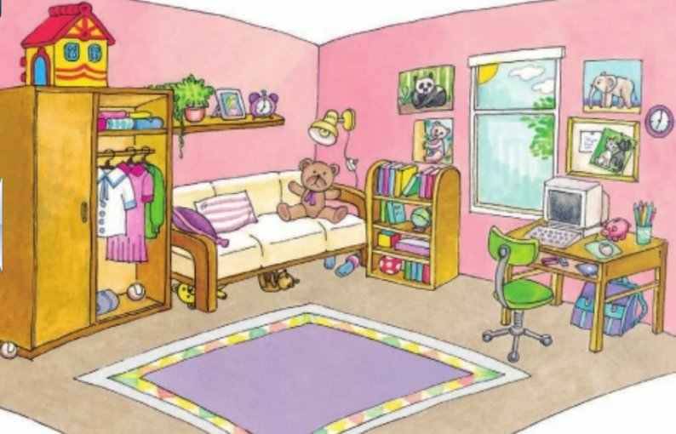

Ex.5.

Вставьте some, any, no или их производные:
- Are there ……… cinemas or theatres in your town? – There aren`t ______cinemas - but there is a theatre festival in summer.
- Is there………… for young people – a zoo, interesting museums? – I`m sorry, there is ______ zoo in our town. But there are…………. museums, _____ discos and every three weeks there is a rock concert for young people here.
- She has _______ sister, she has only brothers.
- Do you know _______ about Chinese art?
- They have……….. cousins in Minsk.
- I have ………… good friends.
- We did not know…………. about his problem: he told us _____.
- Have you got …………..interesting books?
- Have you ________ friends in America?
- He has _______ English books in this bookcase.
- Did you meet _____ on your way to school?
- Have you got………..pencils in your bag?
- Do we have………… chalk on the blackboard?
- How could I know that he was ill? ……… told me _______.
- She has………….mistakes in her test.

Ex. 6 Составьте рассказ “About myself”.
Ex.7. Употребите необходимую форму глагола to be
- My mother … nervous last Saturday.
- The t weather today … cold and rainy.
- Her children … not at home. …..they at home yesterday? ….they ….at home tomorrow?
- They … not in the garden. They … not in the yard. She thought where they could … and became worried more and more.
- They … not in the office at the moment.
- Where … the keys? — They … in your jacket.
- What… the time, please? — It … two o’clock.
- Do you have any idea where he … ?
- Used cars … cheap.
- I don’t remember what his telephone number … .
- Two heads … better than one.
- You … right. That … a lot of money!
- Last week I ….at the café. The coffee … very good there.
- . … this your watch? — Yes, it .. .
- My uncle … an office worker. He … at work. But last year he …..a worker at the factory. I think he …..next year.
- Where … the papers? — They … on the table. 20. I ….glad to hear that.
- Susan _____ the director of a firm. She _____ always on business trips. Yesterday she ______ in Geneva. Tomorrow she ______ in London. Last week she ______ in Chicago. Next week she _____ in New Orleans. At the moment she _____ in Amsterdam. But in two hours she _______ in Paris. At the end of every trip she _____ always tired. She ____ glad to come back home. Now she ______ with her family. Her children _____ very excited. They _____ happy together.

Ex/8. Прочитайте текст
MR. LAVROV’S FAMILY
Paul Lavrov is Head master (директор школы) of the Russian Embassy school in Great Britain. He has a wife and two children – his son Alex is eight and his daughter Ann is twelve. His wife Helen is a teacher of geography. She teaches geography at the Embassy school. Alex and Ann go to school. Paul and his family live in London. They have a three-room flat in a new block of flats. Paul and Helen get up not very early, usually at seven o’clock. They do their physical exercises. Then Paul shaves and takes a shower and Helen wakes up Ann and Alex. Ann and Alex wash their hands and faces, and brush their teeth. After that the Lavrovs have breakfast. They usually have ham, cheese, eggs, tea or coffee with toasts for breakfast. During breakfast they listen to the latest news on the radio. At eight o’clock the school bus takes Ann and Alex to school. Their classes begin at nine. When Helen has a geography class in the morning she also goes to school by the school bus. But if she has a class in the afternoon she goes to school by bus or by tube. Paul drives to the school in his car, it takes him only ten minutes. He usually has a lot of things to do. He looks through class registers, makes phone calls and speaks to the teachers and pupils. Twice or three times a week he visits classes. Paul often has lunch at home. After lunch he goes back to the school. Paul’s working day finishes at six o’clock. In the evening Paul and Helen sometimes go out or have guests at home. Tonight they are going to visit the Browns. It is eight o’clock now. The Browns and their quests are at the table. They are having dinner. Mr. Brown is asking Alex and Ann about their studies. Alex and Ann are answering his questions. After dinner Amy Brown is going to show Ann her new little dog. Yesterday was their week-end. The Lavrovs like to spend their weekends together. Yesterday afternoon after the walk Paul and Alex played chess. Ann helped her mother about the house. In the evening the family gathered at the table. They had tea with cakes and biscuits, listened to music and discussed their plans for the future. They went to bed rather late
Ex. 9 Дайте письменно полные ответы на следующие вопросы.
1 Where do the Lavrovs live?
2. Does Helen go to school by bus or by tube?
3 When does Paul’s working day finish?
4. What do Paul and Helen do in the evening?
5 Who is asking Alex and Ann about their studies?
6 What is Amy Brown going to show Ann after dinner?
Ex.10 Выучите типы судов наизусть.
Ex11.
Поставьте следующие существительные во множественное число (обратите внимание на артикль: неопределенный артикль во множественном числе опускается, определенный сохраняется).
a baby, a plant, a lemon, a peach, a banana, a brush, a star, a mountain, a tree, a shilling, a king, the waiter, the queen, a man, the man, a woman, the woman, an eye, a shelf, a box, the city, a boy, a goose, the watch, a mouse, a dress, a toy, the sheep, a tooth, a child, the ox, a deer, the life, a tomato, a secretary, a crowd, the airport, a theatre, the tornado, a shop, the tragedy.

